Chapter 2 Linear Theory
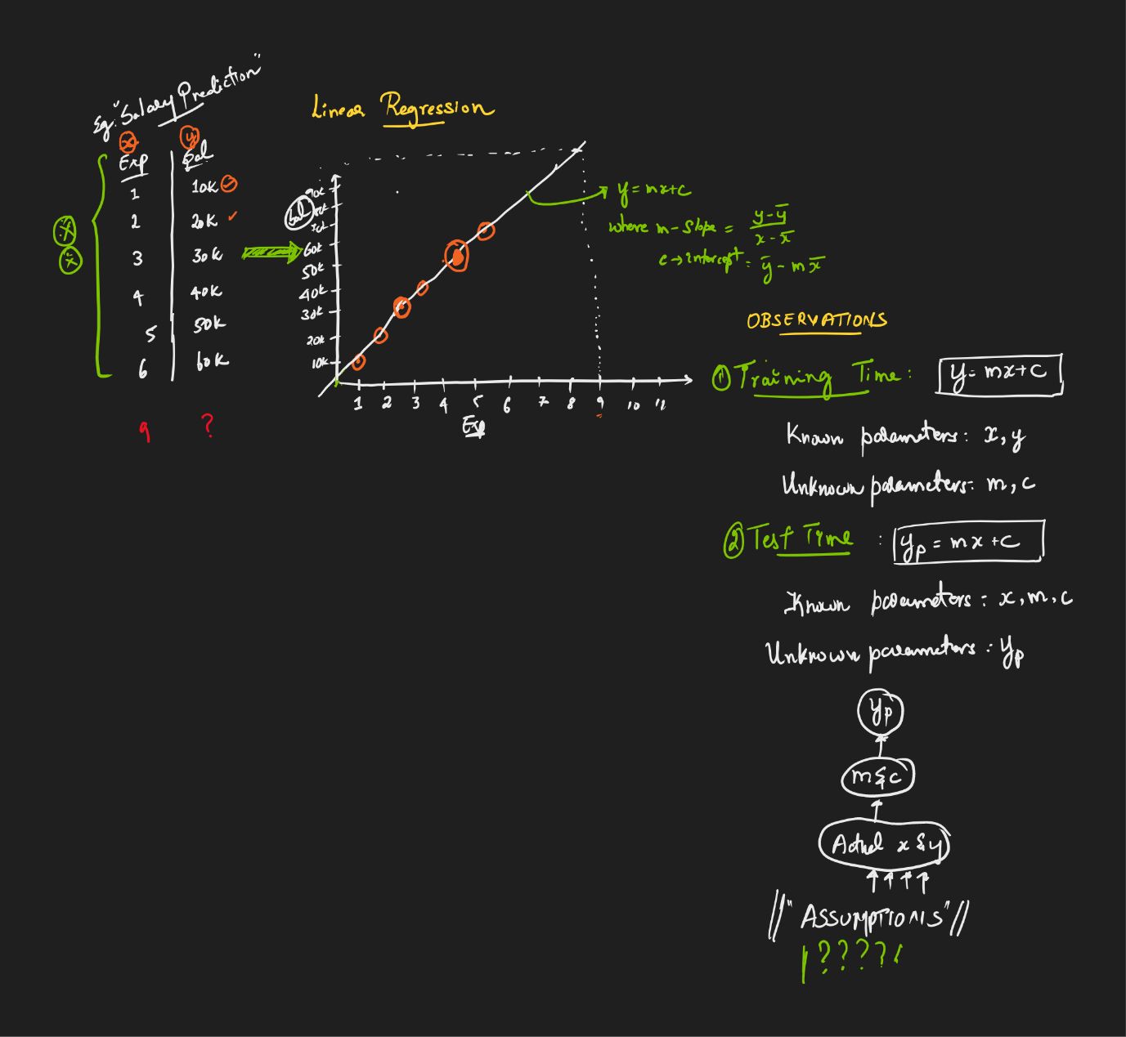



Understand what is Intercept and co-efficient in Linear regression
To predict MPG value with x y = mx+c
M – Coefficient/slope
C- Intercept
Example:
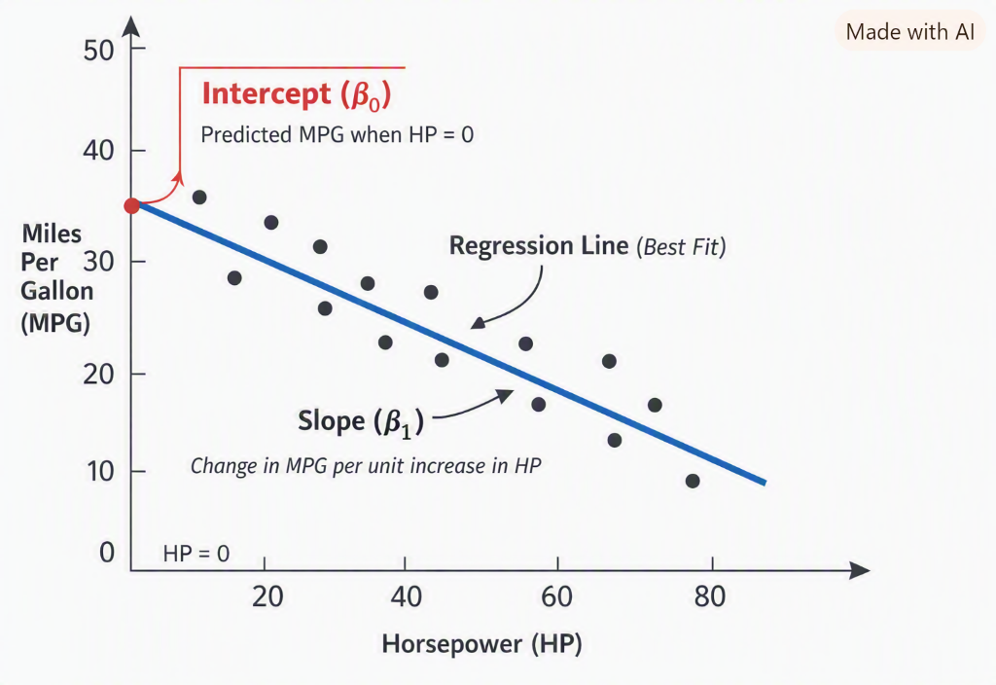
Here’s a diagram to make the intercept crystal clear:
✅ The red dot on the y-axis is the intercept ($β_{0}$).
- It’s the predicted MPG when HP = 0 (all features = 0 in multiple regression).
- Notice it’s not zero — it’s a baseline value chosen by the regression algorithm.
✅ The blue line is the regression line (best fit).
- Its slope ($β_{1}$) shows how MPG changes for each unit increase in HP.
- If slope is negative, MPG decreases as HP increases.
🚗 Intuition
- In the employee salary case, intercept = base salary when experience = 0.
- In the car mileage case, intercept = baseline MPG when HP=0 (hypothetical, since cars don’t really have HP=0).
- The intercept is simply the y-axis crossing point of the regression line, while the slope is the tilt of the line.

The internal linear algorithm will take to find M(Coefficient) & C (Intercept), if the dataset is exactly in linear way then we will get the best fitted line, but if it is non-linear algorithm will take care with error value and finally draw the slope in common.
Example: when emp exp 1 yr, 20K 2yr, 30K, 3yr 10K, then best fit line will not come.

